**INDUSTRIAL ASSIGNMENT REPORT**

**ON**

**“PREDICTING PERSONAL LOAN APPROVAL USING**

**MACHINE LEARNING”**

***Submitted in partial fulfillment of the requirements for the award of the degree of***

***BACHELOR OF SCIENCE***

***ON***

***COMPUTER SCIENCE***

***Submitted By***

***Team Leader***

***C.Subhalakshmi(Reg:20201371506141)***

***Team Members***

***S.Mageshwari(Reg:20201371506115)***

***V.Madhumitha(Reg:20201371506114)***

***A.Seema Ruththira Selva(Reg:20201371506135)***



***Department of Computer Science***

***Government Arts and Science College For Women,Alangulam***

***Tenkasi - 627851*PREDICTING PERSONAL LOAN APPROVAL USING**

**MACHINE LEARNING**

1 **INTRODUCTION**

Predicting loan approval using machine learning is a process of using historical data and statistical algorithms to predict the likelihood of a loan being approved or rejected. This approach can help automate the loan approval process, improve accuracy, and reduce the time and resources required for manual loan decisions. Traditionally, loan decisions have been made by human experts who evaluate a borrower's financial history, credit score, income, employment status, and other factors to determine whether to approve or reject a loan application. machine learning has become increasingly popular in the financial industry, and many banks and lending institutions are now using machine learning models to predict loan approvals. These models can improve loan decision-making, reduce the risk of defaults, and ultimately help lenders provide better service to their customers.

**1.1 Overview**

Predicting loan approval using machine learning involves building a model that uses historical data to predict the likelihood of a loan being approved or rejected. The goal is to use the model to automate the loan approval process and improve the accuracy of loan decisions. The machine learning model can be built using supervised learning algorithms such as logistic regression, decision trees, and random forests.

**1.2**  **Purpose**

The purpose of predicting loan approval using machine learning is to automate and improve the loan approval process. Traditionally, loan decisions have been made manually by human experts, which can be time-consuming, subjective, and prone to errors. By using machine learning algorithms, banks and lending institutions can speed up the loan approval process, reduce costs, and improve the accuracy of loan decisions.

**2 Problem Definition & Design Thinking**

**2.1 Empathy Map**

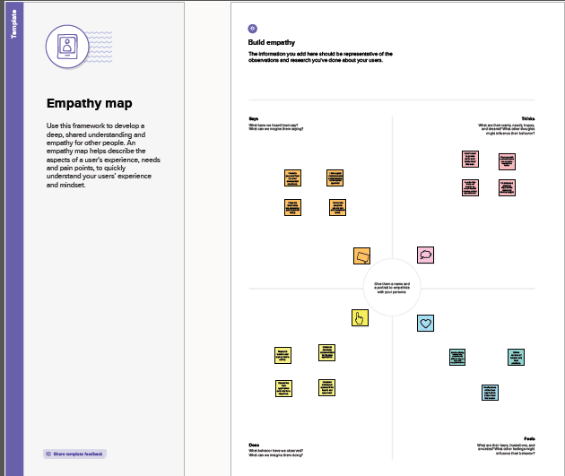

**2.2 Ideation & Brainstorming Map**

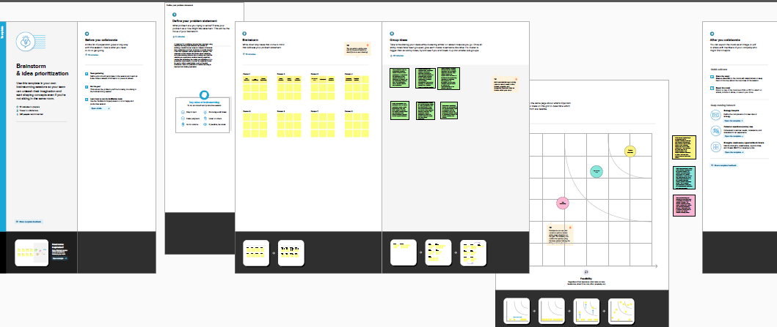

**3 RESULT**

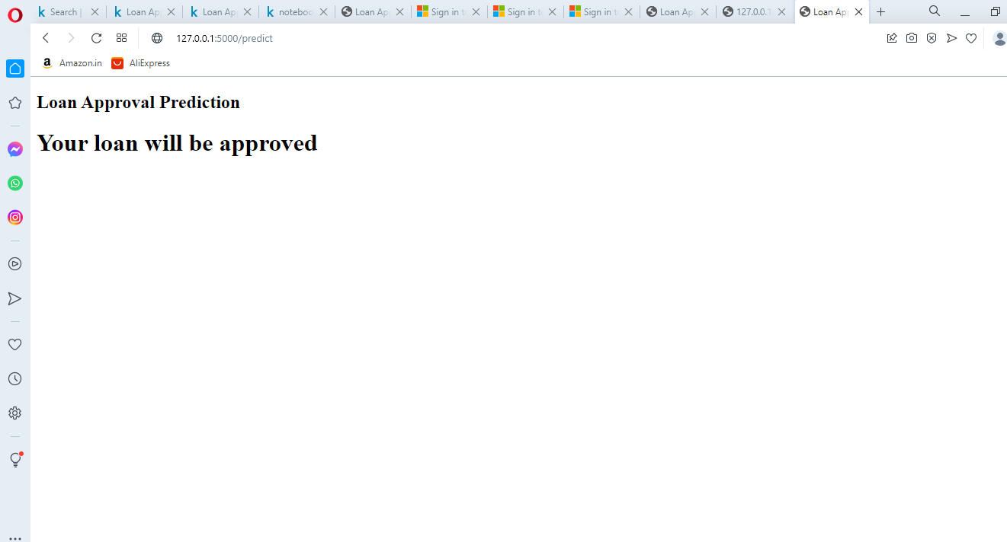

**4 ADVANTAGES & DISADVANTAGES**

**4.1 Advantages**

* Faster decision-making: Machine learning algorithms can quickly process vast amounts of data, enabling lenders to make faster and more informed decisions about loan approvals.
* Improved accuracy: By analyzing historical data, machine learning models can identify patterns that humans may miss, leading to more accurate predictions of loan approval.
* Personalization: Machine learning algorithms can consider individual characteristics such as credit history, employment status, and income to personalize loan approval decision.

**4.2 Disadvantages**

* Limited data availability: Machine learning models require large amounts of historical data to make accurate predictions. If there is limited data available, the model may not be accurate or may require additional data to improve its performance.
* Over-reliance on historical data: Machine learning algorithms rely on historical data to make predictions. If the data is biased or incomplete, it can affect the accuracy of the model.
* Lack of transparency: Machine learning models can be complex, making it difficult to understand how the algorithm makes its predictions. This can make it challenging for lenders to explain decisions to borrowers or regulators.

1. **APPLICATIONS**

* Credit scoring: Machine learning can help lenders predict the creditworthiness of borrowers by analyzing their credit history, income, employment status, and other factors. This can help lenders make more accurate and objective loan approval decisions.
* Fraud detection: Machine learning algorithms can detect fraudulent loan applications by analyzing patterns in historical data and identifying unusual behavior or anomalies.
* Risk assessment: Machine learning can help lenders assess the risk associated with a loan application by analyzing historical data and identifying potential risks and mitigating .

1. **CONCLUSION**

In conclusion, using machine learning to predict personal loan approval can provide lenders with several benefits, including faster decision-making, improved accuracy, personalization, reduced bias, risk mitigation, and improved customer experience. Machine learning can help lenders analyze vast amounts of historical data to identify patterns and make accurate loan approval decisions based on objective criteria. However, there are also some potential disadvantages to consider, such as limited data availability, over-reliance on historical data, lack of transparency, security concerns, and legal and ethical considerations. Therefore, lenders should carefully consider the potential benefits and risks of using machine learning in loan approval decisions and ensure they are making informed and ethical decisions.

**7 FUTURE SCOPE**

* Enhanced personalization: Machine learning algorithms can personalize loan offerings by analyzing a borrower's credit history, income, and other relevant factors. In the future, this technology can be further developed to offer more personalized loan products tailored to individual borrowers' needs and preferences.
* Explainability and transparency: As machine learning algorithms become more complex, there is a need for increased transparency in the decision-making process. Future developments can focus on enhancing the interpretability and explainability of machine learning models to make loan approval decisions more transparent and understandable to borrowers.
* Integration with other technologies: Machine learning can be integrated with other technologies such as blockchain and the Internet of Things (IoT) to enhance data privacy, security, and accuracy in personal loan approval decisions.

**8 APPENDIX**

**8.1 Source Code**

